**Please note:** Everyone should start with **WHY** they’ve chosen that particular technique or method (why world map, why scatterplot, why boxplots, …), then proceed to the **HOW** (using the alphabet of visualization from the lecture e.g. marks like line, position, color, size and channels like color hue, shape, …) and then finish with **WHAT** they can see when looking at the result.

Name in brackets are the presenters for each section. We should stick to 1,5 minutes each, so that no one has to fill the missing minutes or speed up to make up for the overspend minutes by the team mates 😉

**IMPORT** (Vangel)

**LOAD DATA** (Vangel)

**MERGE DATA** (Vangel)

**HELPER VARIABLES / RENAME/SHORTEN COLUMN NAME** (Vangel)

**SHOW DATA** (Vangel)

Data Completeness

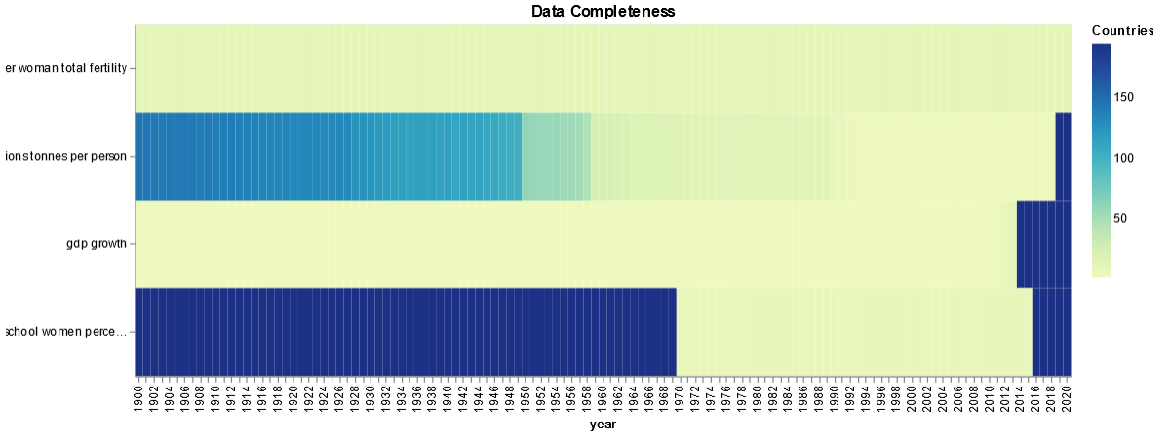

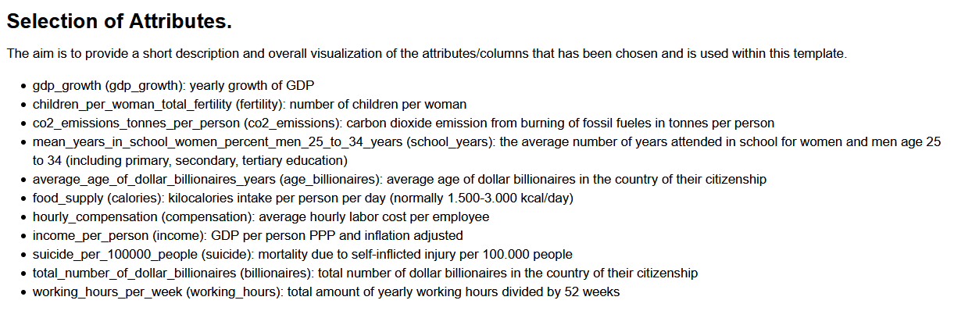

Scatterplot (from Johannes Jupyter Notebook)

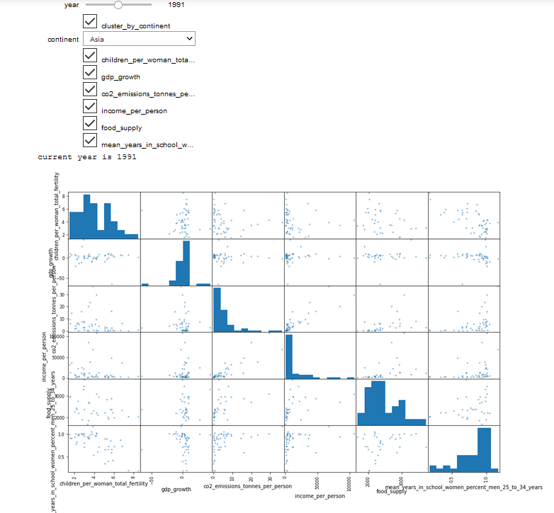

**DESCRIPTIVE STATISTICS (Hendrik)**

Analyzing our dataset using descriptive statistics on the level of individual attributes.

This includes simple plots of distributions and statistics.

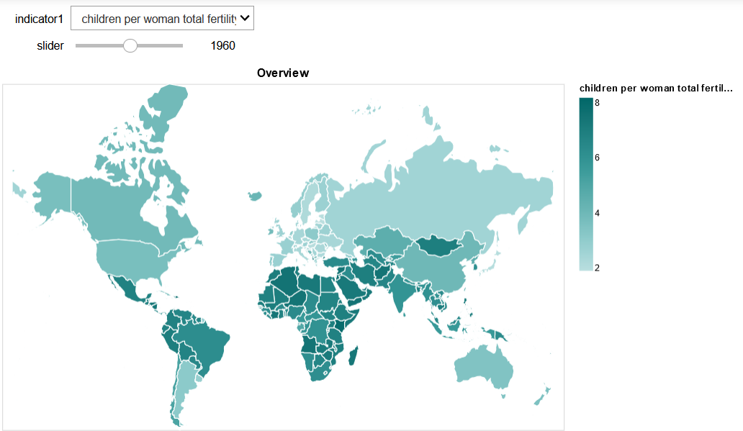

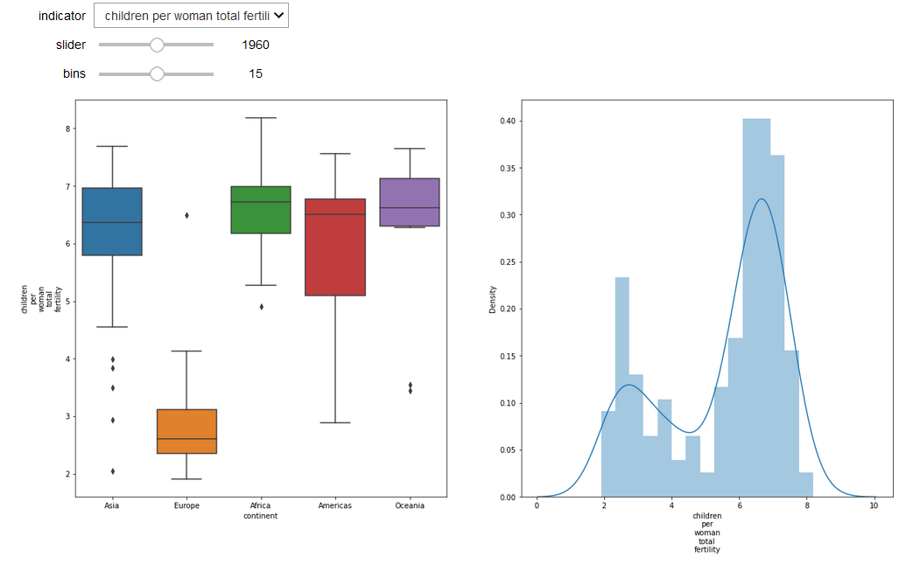

The graphs reveal that the number of babies per woman has dropped in every continent during the last 60+ years. More evident in Asia, America and Oceania. While Europe's change in the past 60 years was not as significant. Even in Africa the count of babies per woman has dropped, but still remains higher than the other continents.

**CORRELATIONS (Paula)**

Analyzing our dataset by looking at correlations between attributes (dimensions) and coming up with an interpretation why in which way specific attributes are correlated.

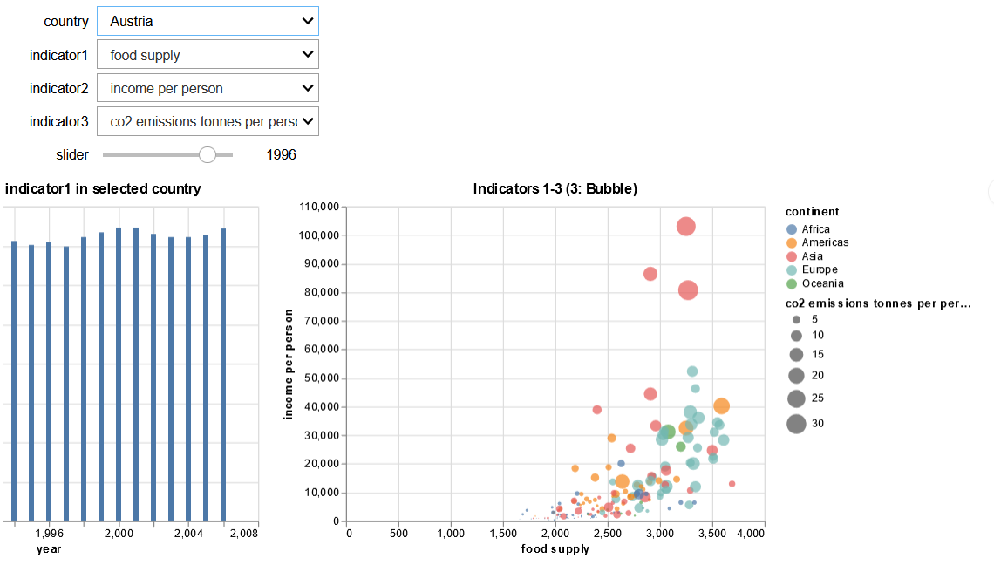

Interestingly a lot of Asian countries that are not mentioned a lot in the media have high income per person in the early 60's and keep the status throughout the 2000's (Brunei, Kuwait, Saudi Arabia). With United Arab Emirates speeding up in the end of the 60's (with forming of UAE) and overtaking them in less than a couple of years. As expected, calories intake as well as Co2 emission keep increasing with those countries.

African countries increase their income per person as well but not as much as their food supply.

**CLUSTERING (Johannes)**

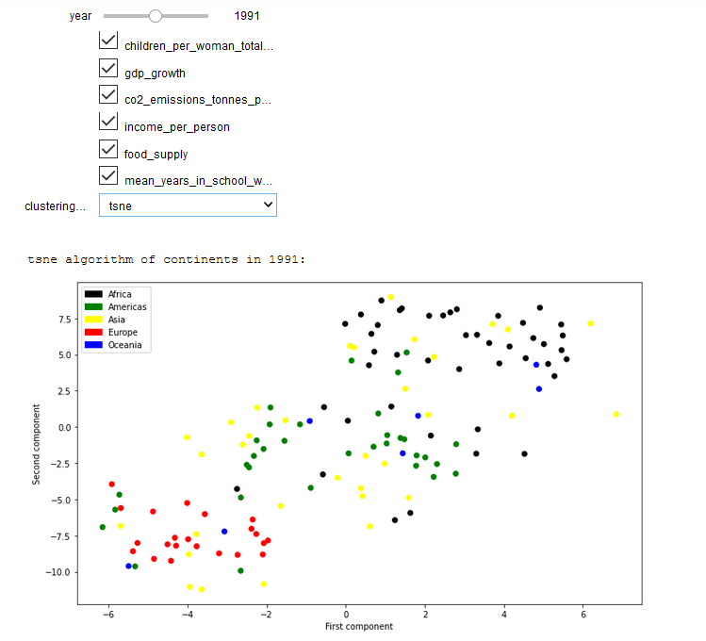

Trying to make the above plot interactive with using altair instead of plotlib. So it looks like Hendrik’s one.

Second visualization should be a histogram with maybe boxplots for the chosen attributes (from the cluster visualization). So that we return from 2D to multidimensional view.

